**REPORT OF ACTIVITIES OF AU/CIEFFA. JANUARY-DECEMBER 2016**

The African Union - International Centre for the Education of Girls and Women in Africa (AU/CIEFFA) is a specialized institution of the African Union since 2004, dealing with women and girls’ education following Decision Assembly/AU/DEC.44 (III). The centre is located in Ouagadougou, Burkina Faso.

This report outlines the activities undertaken by AU/CIEFFA from January –December 2016. it comprises two main parts:

1. Operationalization of AU/CIEFFA
2. Activities addressing AU/CIEFFA’s mandate
3. **Operationalization of AU/CIEFFA**
   1. **Legal status of AU/CIEFFA**

Following the Assembly Decision of AU heads of States and Government, Assembly/AU/Dec.44(III), the Legal Counsel proposed that whilst AU/CIEFFA is being integrated in the AUC system, statutes need to be developed. These statutes have been endorsed by the Department of HRST and by Legal Counsel. They will be presented to the Specialized Technical Committee (STC) on Education, Science and Technology in March 2017. These will then be considered by the STC on Legal Affairs in September/ October 2017 and adopted by AU Policy organs in January 2018.

There has also been an exchange of letters as well as a meeting between AUC and UNESCO on maintaining the status of UNESCO Category 2 institution. It has been agreed that UNESCO will continue to be represented in AU/CIEFFA’s Steering committee.

* 1. **Staffing of AU/CIEFFA and relocation to Ouagadougou, Burkina Faso**

The international staff, the Coordinator, the Senior Policy Officer and the Policy officer -ICT & Documentation have moved to Ouagadougou since 1st September 2016. The recruitment of three other regular staff is currently underway.

The local staff currently in the Ouagadougou office consists of eleven persons, both professional and General Service officers. They are seconded from the host country and secondment letters have been issued by the Administration and Human Resources Department of the AUC on their conditions of service.

1. **Programme activities**

During this period from January to December 2016, the following activities were undertaken by AU/CIEFFA:

**2.1 8th African Union Gender Pre-Summit**

AU/CIEFFA organized a session on “*Girls and Women’s Education in Africa with emphasis on STEM (*Science, Technology, Engineering and Mathematics) *and TVET (*Technical Vocational Education and Training)*”* on 20th January 2016 during the Gender Pre-summit, which took place from 18th– 20th January 2016, on the margins of the AU Summit of Heads of States and Government.

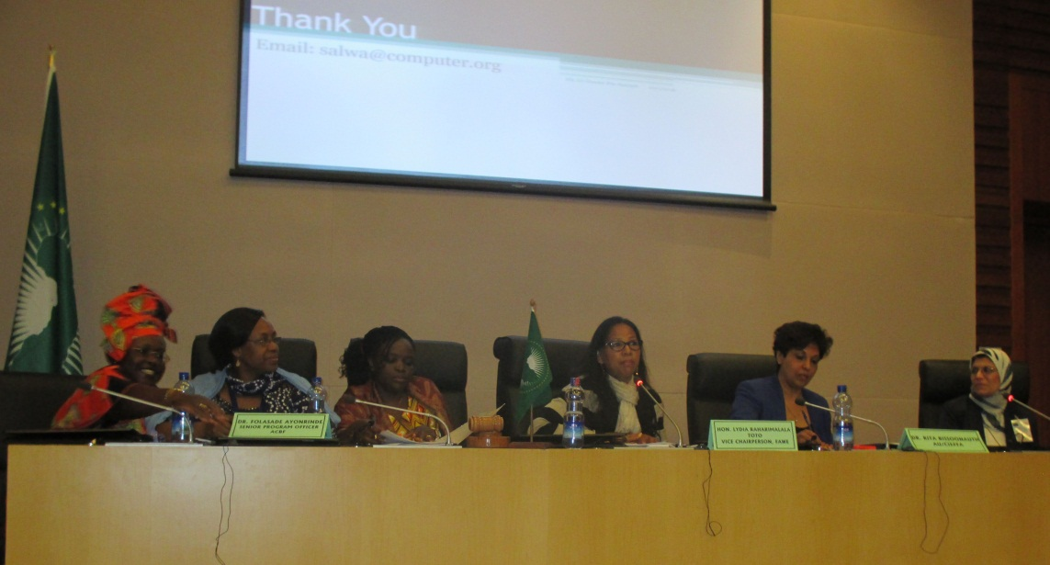

The session focused on the importance of increasing women and girls’ participation in STEM and TVET education towards achieving the African Union’s Agenda 2063. Taking in account the latest progress made in the area of education on the continent, the panelists shed light upon challenges that still kept girls and women out of school. Some of the challenges include high dropout rates especially in the areas of Science and Technology, deeply rooted societal attitudes, societally unvalued TVET, outdated STEM policies which remain frozen in post-colonial frameworks, high illiteracy rates of women and girls, a lack of role models for girls and women in STEM positions and a lack of gender disaggregated data.

**2.2 3rd High Level Panel on Gender equality and women empowerment**

AU/CIEFFA organized a session on gender equality and education in Kigali, Rwanda on the 9th July 2016, in the 3rd High Level Panel on Gender Equality and women empowerment, on the margins of the July 2016 AU Summit. The session was divided in two parts: the first part was on listening to young girls and learning about their aspirations, as well as engaging them in decision-making processes; the second part was on challenges faced by partners in ensuring access to education and retention of girls in schools in the African continent.

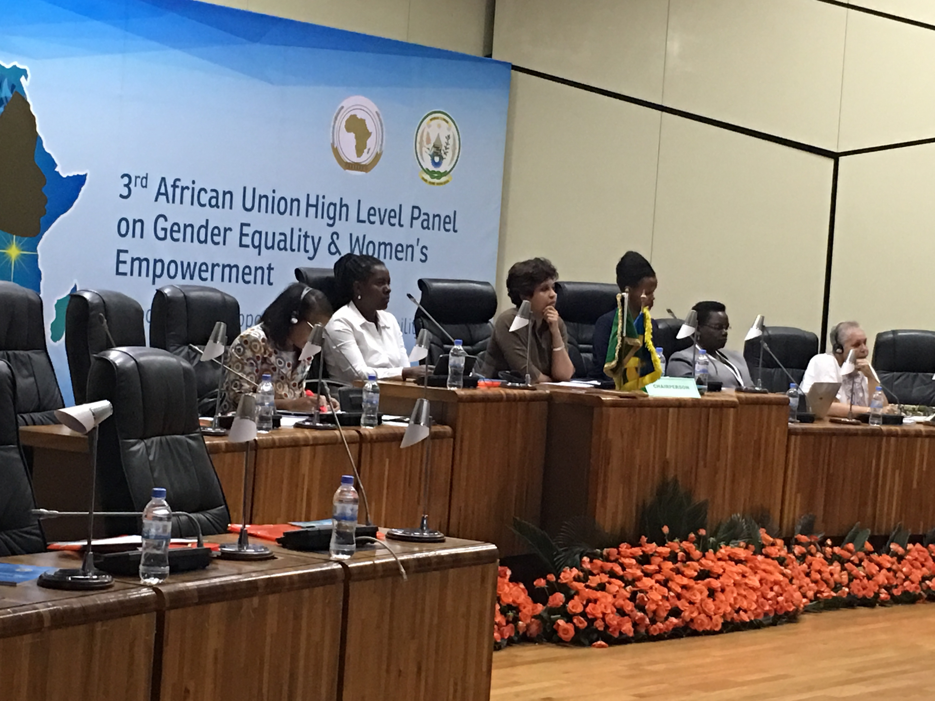

The general recommendation was to call upon governments to adopt a holistic approach through meaningful collaboration among relevant ministries in realizing girls’ rights to access, remain and completing their education, especially secondary and higher education levels.

**2.3 Developing Strategies for retention of girls in schools**

AU/CIEFFA in collaboration with UNESCO has prepared in-depth case studies of five countries providing education to diverse groups of learners, with special emphasis on girls’ education in the five geo-political regions of the continent. These five case studies have been published in one synthesis report with a cross-national approach.

As a follow-up to these case studies, a meeting will be held in Paris in in November 2016 with representatives of AU Member States based in UNESCO, researchers from member states, civil society and RECS to discuss on the implementation of the recommendations made in the report, especially on the need for more and better research on inclusive education and developing monitoring and evaluation frameworks on legal aspects of girls and women’s education.

**2.4 Validation workshop on Institutional and legal environments for Rights of girls and women in education**

AU/CIEFFA will be organizing a meeting in Ouagadougou in the 1st week of December 2016 with development partners and the civil society to validate findings on the analysis of institutional and legal instruments in Member States relating to girls and women’s education in AU Member States and to propose strategies to ensure reinforcement of these legal instruments.